1. 1. A screenshot of a computer

      Description automatically generated
   2. 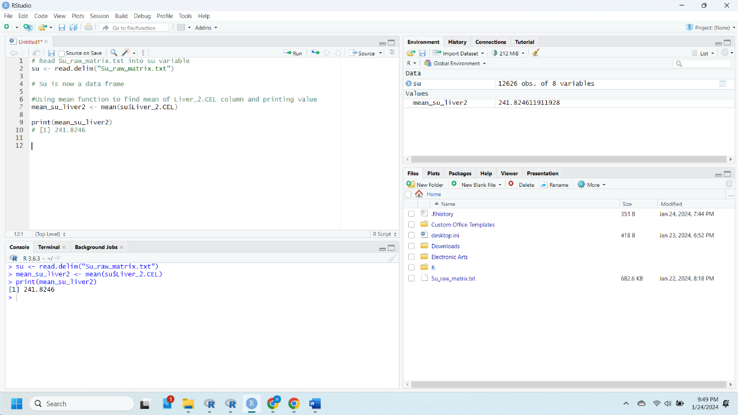

* 1. 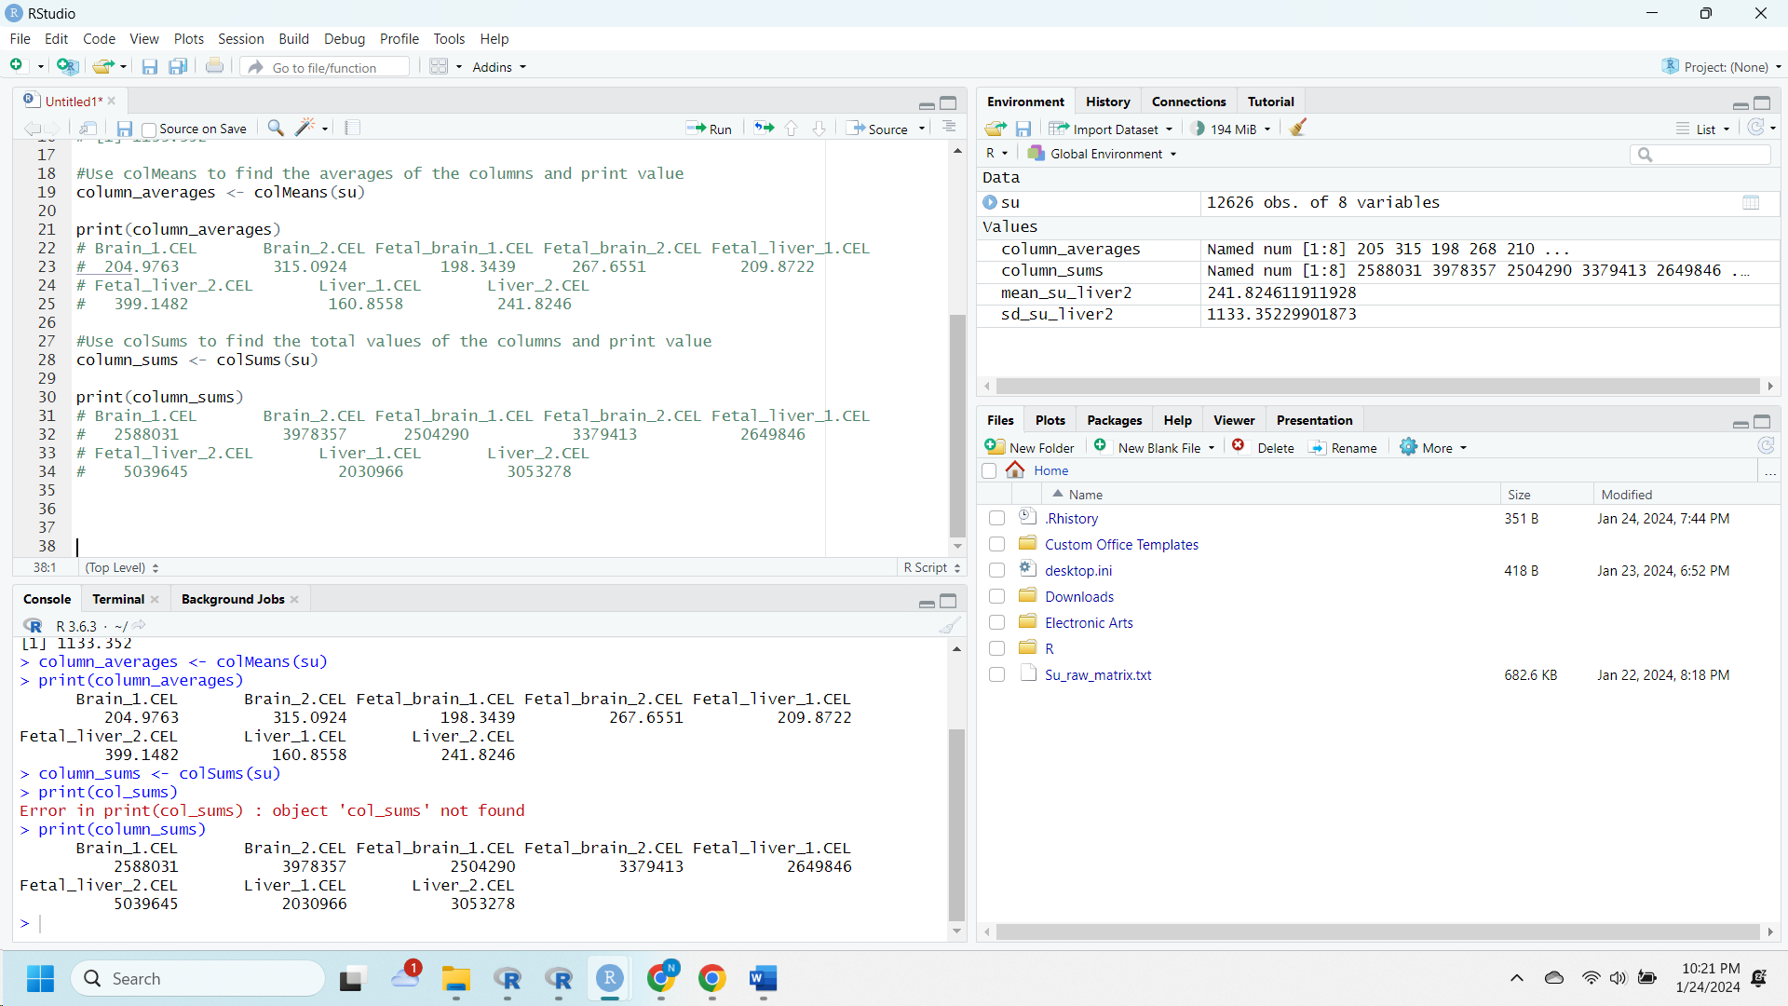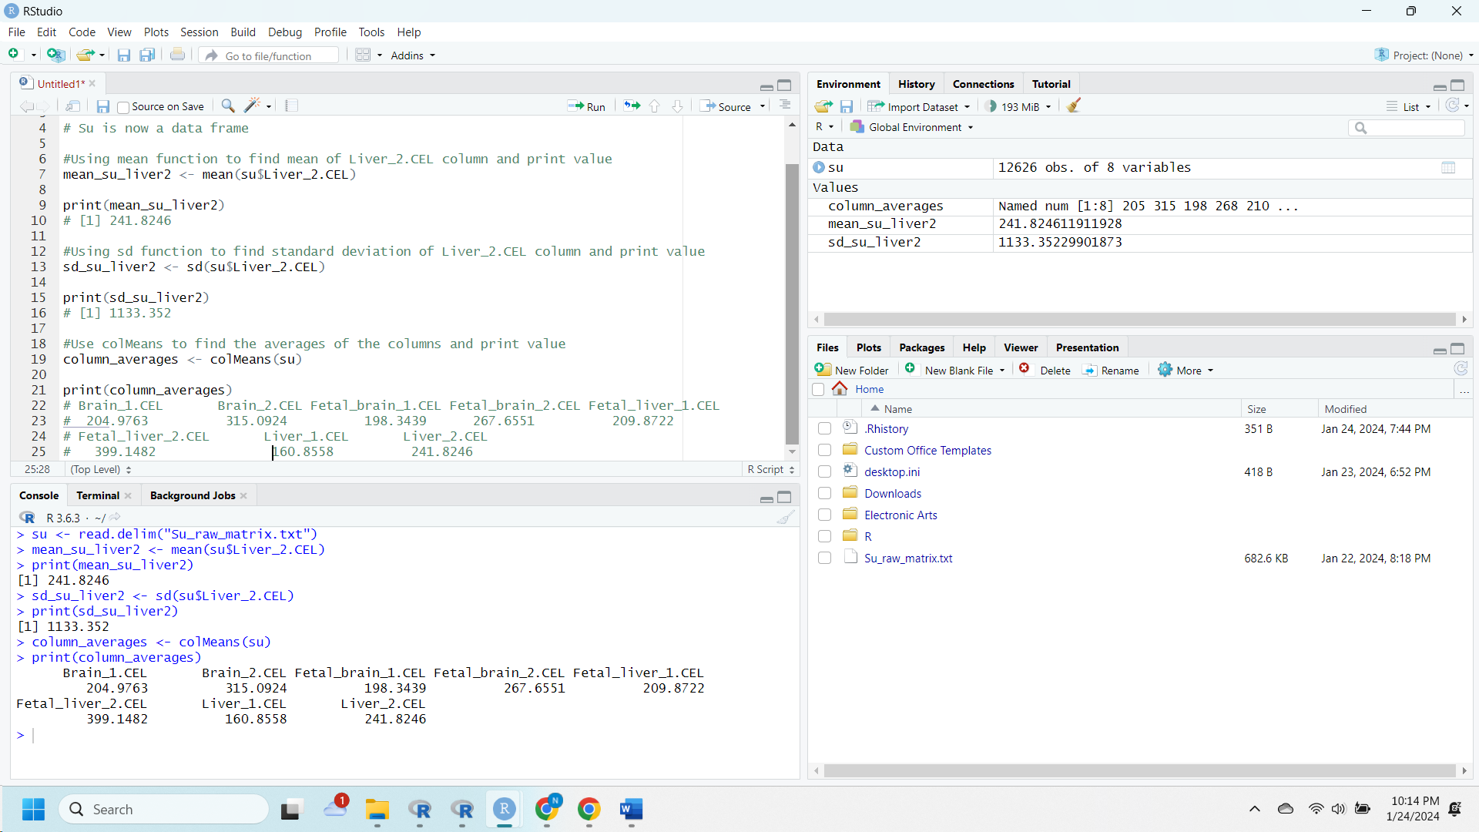

1. These histograms are different with Histogram B being more dispersed value wise and having a lower frequency than Histogram A. The reason for the difference is because the standard deviation for B is higher causing for it to be more dispersed.
   1. A screenshot of a computer

      Description automatically generated Went back and redid A after B due to forgetting xlim.

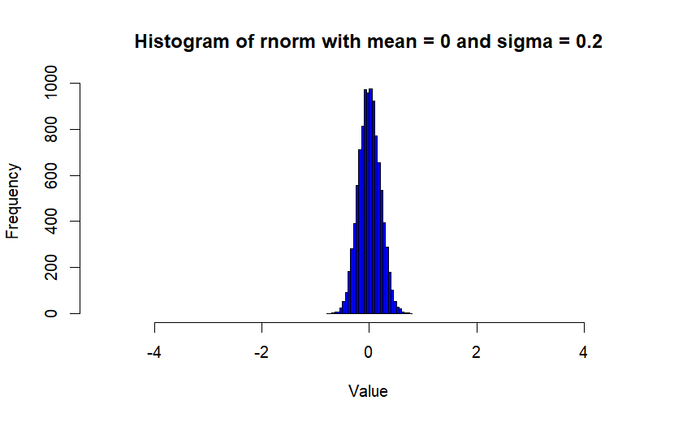

* 1. 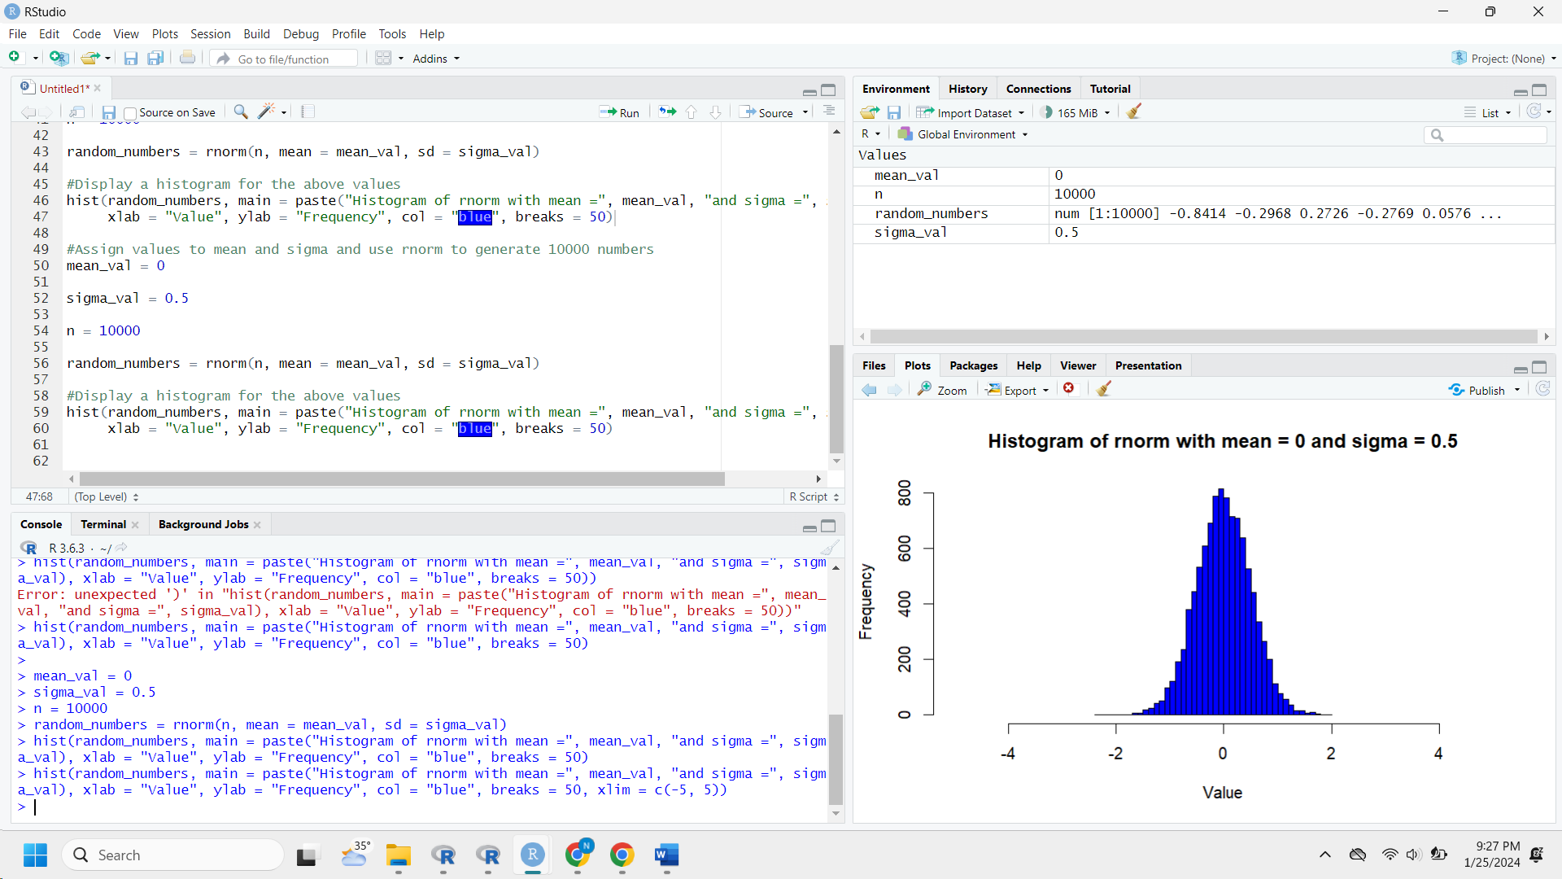

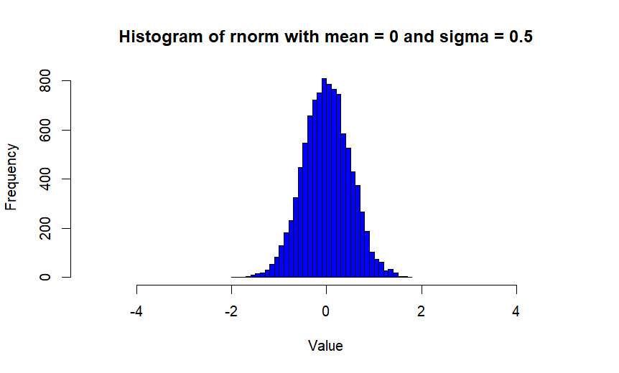

1. 1. 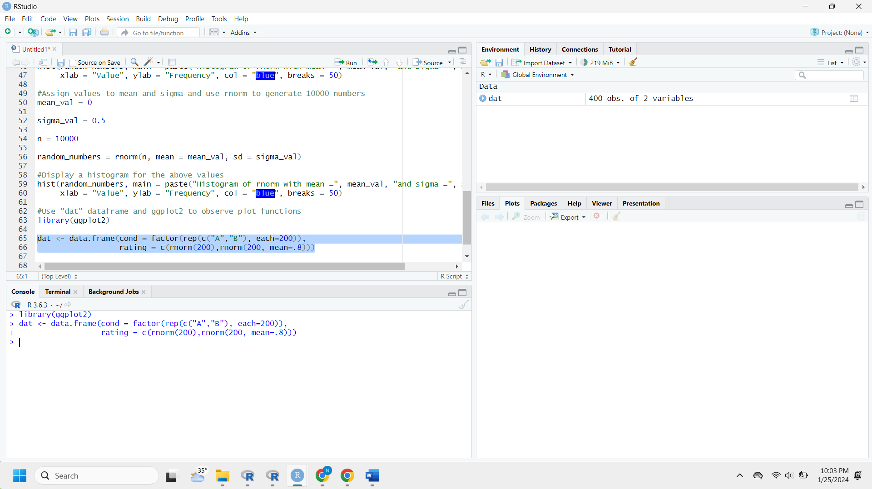
   2. A screenshot of a computer

      Description automatically generated

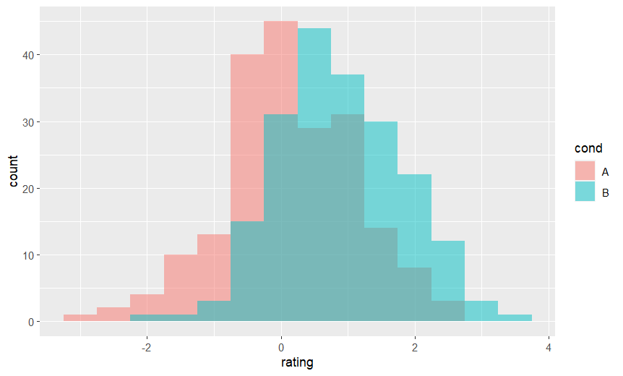

* 1. A screenshot of a computer

     Description automatically generated

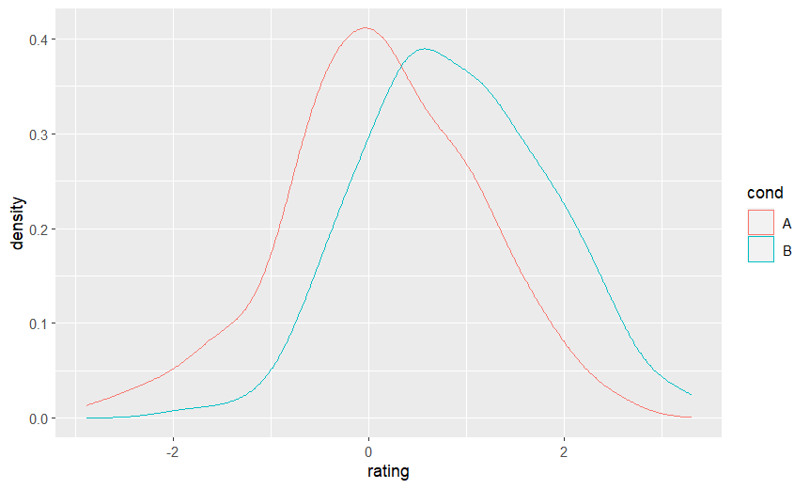

* 1. 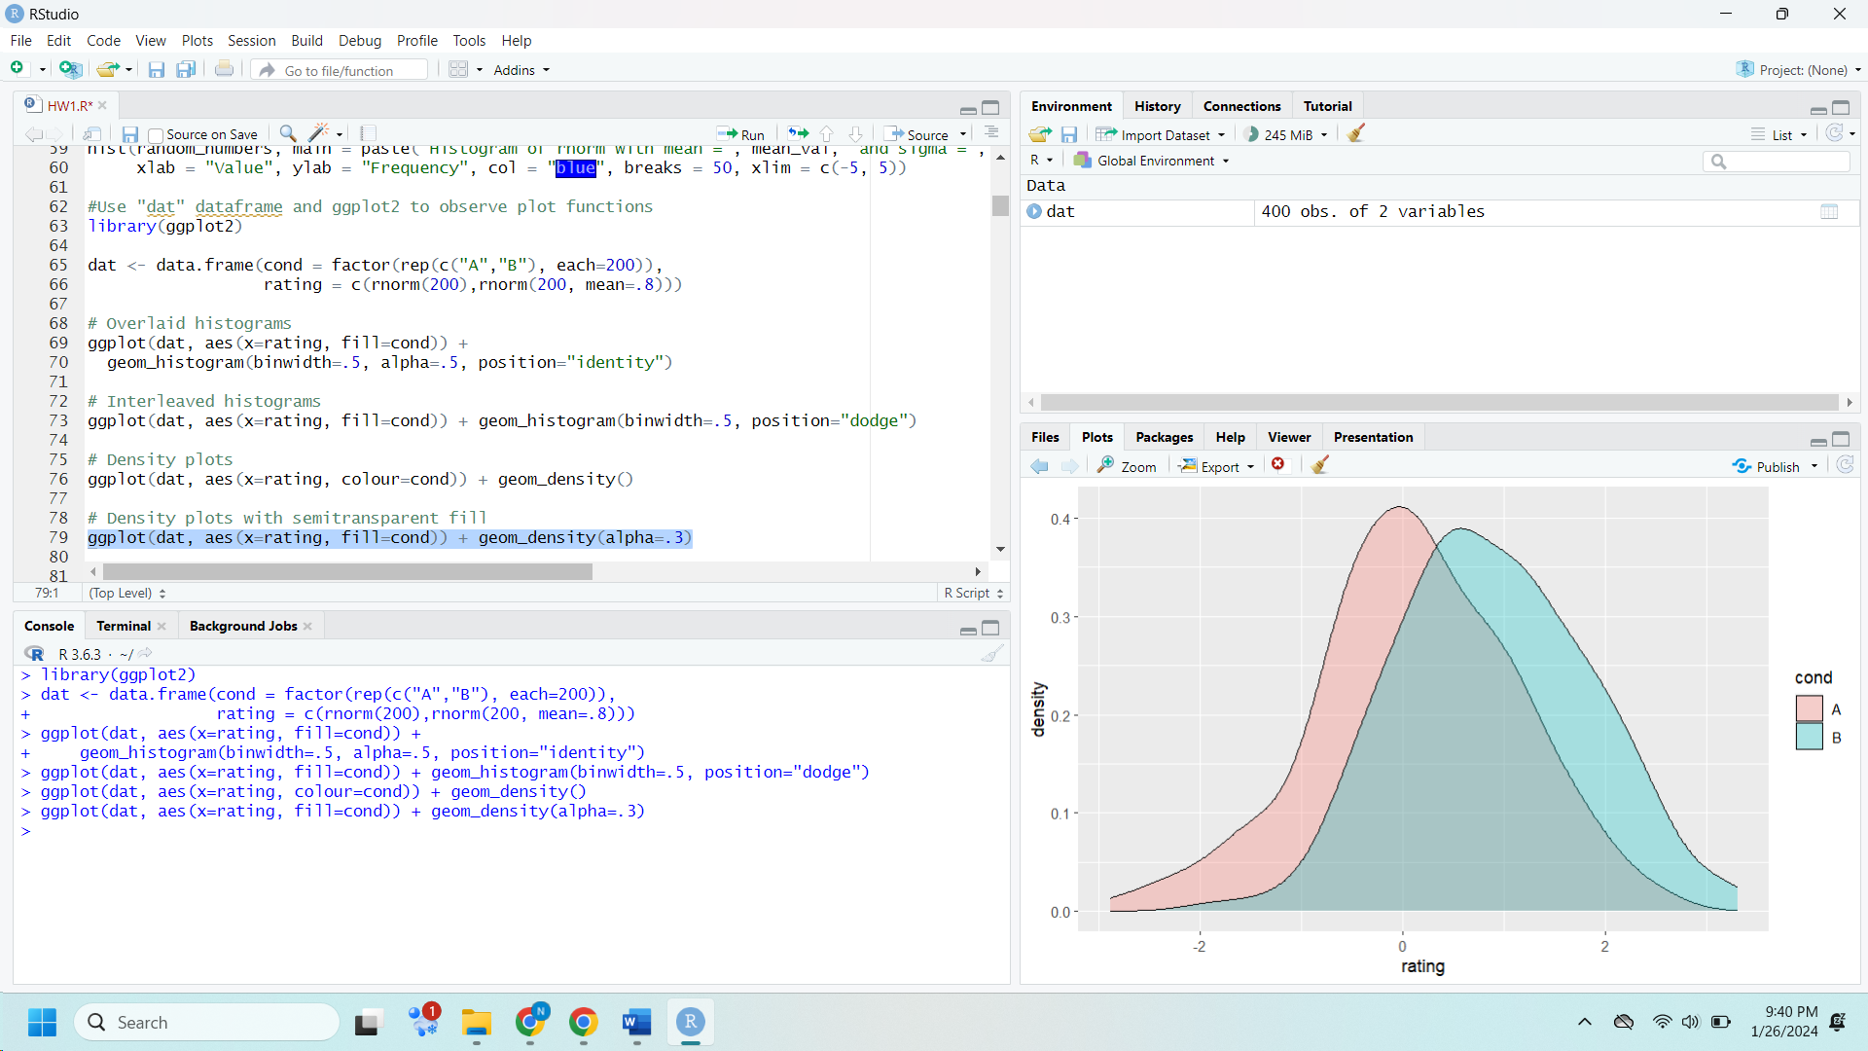

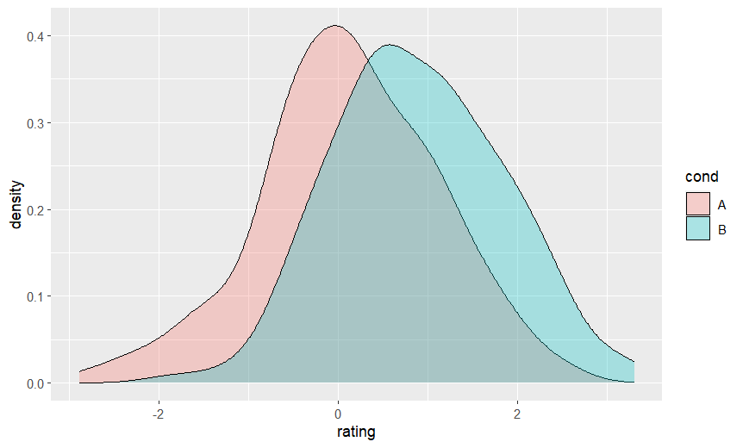

* 1. A screenshot of a computer

     Description automatically generated

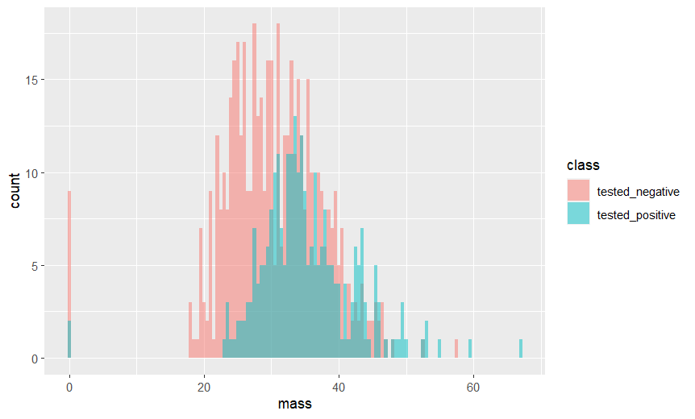

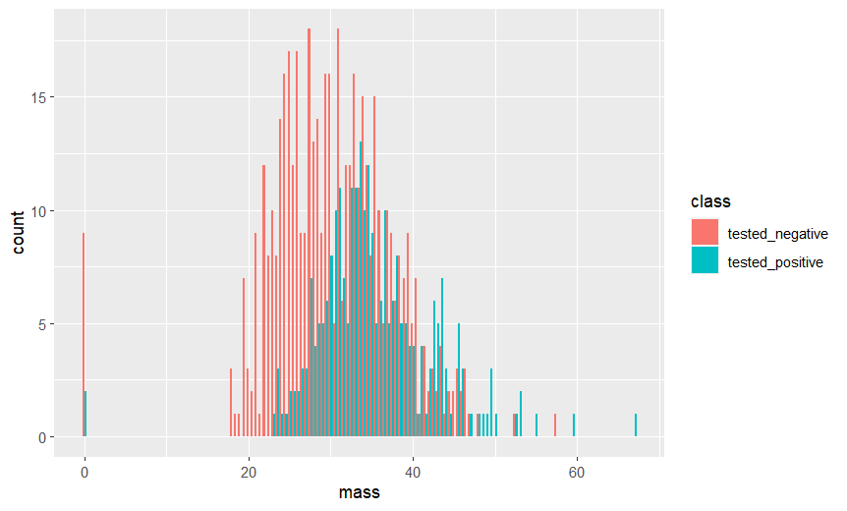

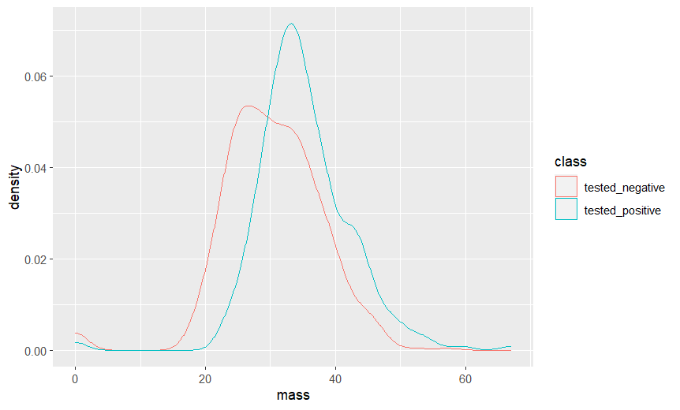

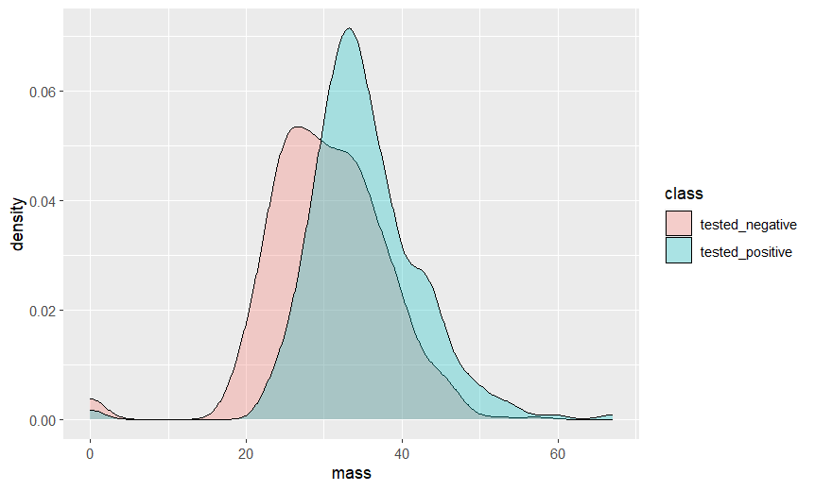

1. A screenshot of a computer

   Description automatically generated
   1. The following will drop any rows missing values and provide a statistical summary
      1. passengers %>% drop_na() %>% summary()

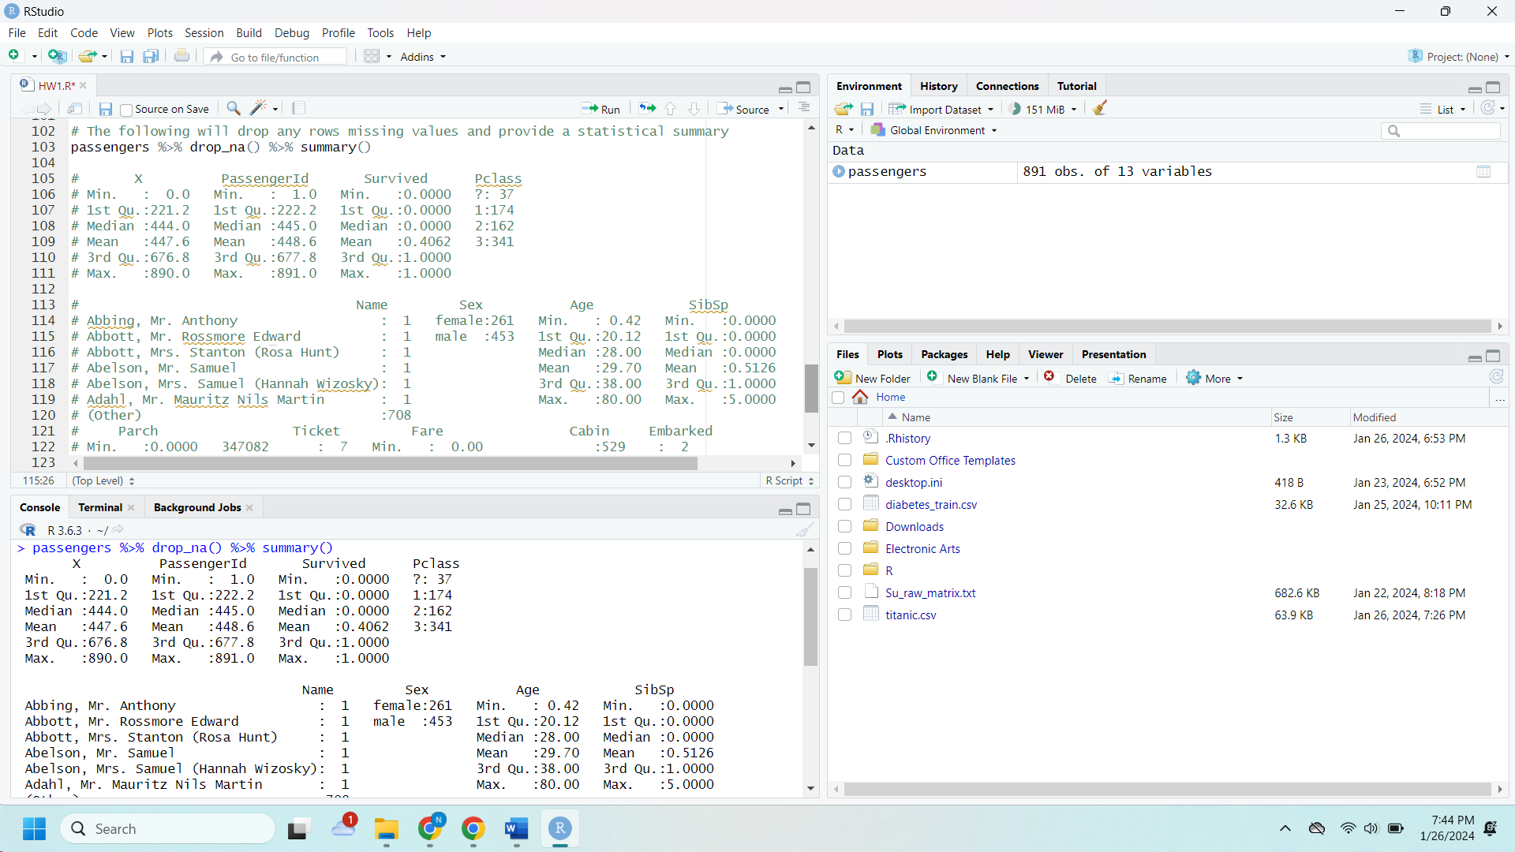

* 1. The following will only produce data where the value of 'Sex' is male
     1. 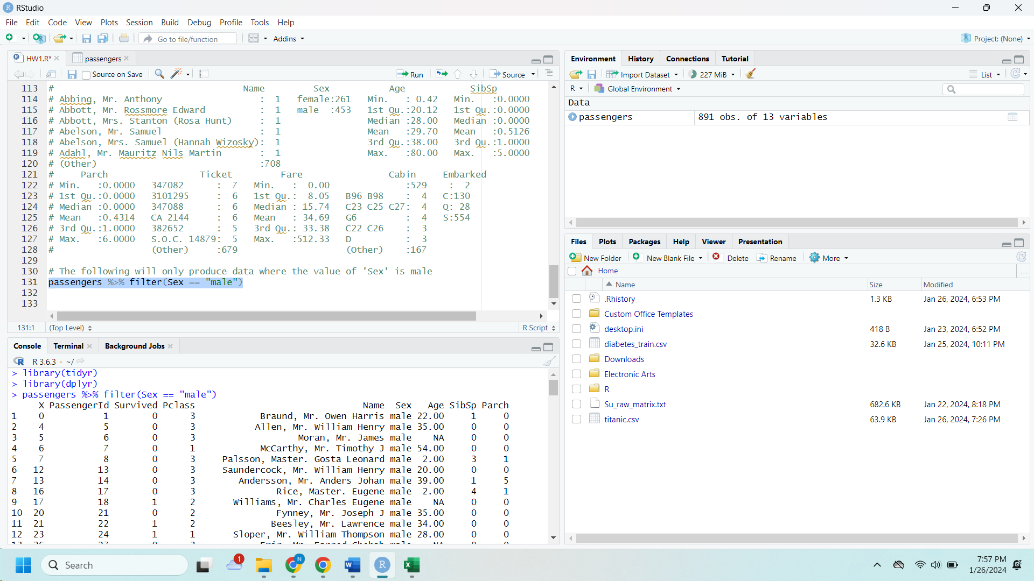passengers %>% filter(Sex == "male")
  2. The following sorts the data frame from highest to lowest 'Fare' value
     1. 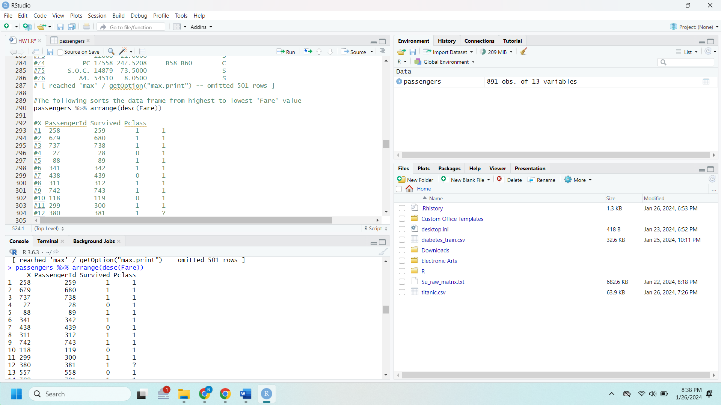passengers %>% arrange(desc(Fare))
  3. The following adds a new column to the data frame called "FamSize" which is the sum of "Parch" and "SibSp" columns, calculating the family size for each passenger
     1. A screenshot of a computer

        Description automatically generatedpassengers %>% mutate(FamSize = Parch + SibSp)
  4. The following will list summary statistics for average fare and total number of survivors separately for each sex category
     1. A screenshot of a computer

        Description automatically generatedpassengers %>% group_by(Sex) %>% summarise(meanFare = mean(Fare), numSurv = sum(Survived))

1. A screenshot of a computer

   Description automatically generated